|  |
| --- |
| LOVELY PROFESSIONAL UNIVERSITY |
| WORKING MECHANISM AND FUNCTIONS OF VARIOUS PARTS OF WATER PURIFIER |
|  |
|  |
| **SAMHITHA MADALA** |
| **11/23/2022** |

|  |
| --- |
|  |

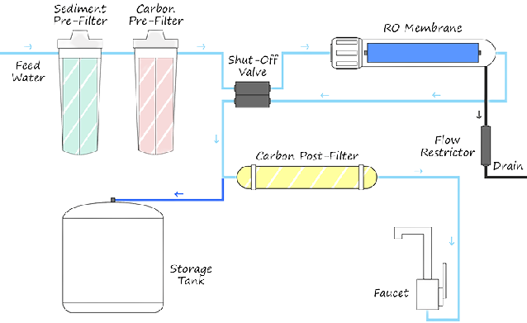



NAME: SAMHITHA M

SEC: K22CT

REG.NO: 12214200

Abstract

This report gives an account of working mechanism and functions of various parts of water purifier. The objective is to show the functions of water purifier. The functions and mechanism of water purifier and its trends are discussed. These days, finding pure, clean, and safe drinking water is difficult. This is brought on by factors such as population growth, industrialization, and environmental deterioration. Given this circumstance, it is even more crucial for us to be knowledgeable about water filtration methods and the products that are on the market to guarantee the purity of our drinking water. Finally the optimum of purifier characteristics and mechanism are brought out.

INDEX

|  |  |  |
| --- | --- | --- |
|  |  |  |
|  |  |  |
|  |  |  |
|  |  |  |
|  |  |  |
|  |  |  |
|  |  |  |
|  |  |  |
|  |  |  |
|  |  |  |
|  |  |  |

INTRODUCTION

This project is allotted by Dr.Amit Bindra Lovely Professional University, Jalandhar, and Punjab. In this project, I am discussing about working mechanism and various function of water purifier and before going on with working mechanism, let’s know about what is water purifier? And why it is essential in daily lie.

**WATER PURIFICATION** is the process of purifying water involves taking out unwanted chemicals, biological pollutants, suspended particles, and gases. Water purifiers guarantee that you have clean and safe drinking water on demand, preventing water-borne infections. Through the purifying process, pollutants such suspended particles, parasites, bacteria; algae, viruses, and fungus are reduced in number. From big (such as for a whole city) to tiny scales, water purification occurs (e.g., for individual households). The majority of populations rely on natural bodies of water as their primary input sources for drinking and daily usage. These resources typically consist of subterranean aquifers, creeks, streams, rivers, and lakes and can be broadly categorized as surface water or groundwater. Oceans and salty seas are now employed as alternate sources of water for drinking and domestic usage thanks to recent technical breakthroughs.

Water filtering methods include Reverse Osmosis Water Filtration (RO), Ultra Filtration (UF), and Ultra Violet disinfection (UV).

**REVERSE OSMOSIS WATER FILTERATION:** A semi-permeable membrane is used in reverse osmosis water treatment.

This membrane technology is not a filtering technique. In reverse osmosis, an applied pressure is utilized to counteract osmotic pressure, which is a collative property governed by chemical potential, a thermodynamic characteristic. Reverse osmosis over a semi-permeable membrane may remove many different types of molecules and ions from solutions and is utilized in both industrial operations and potable water production.

The most prevalent use of reverse osmosis is in the filtration of drinking water from saltwater and in locations where water pollution includes viruses and chemicals such as metal ions, lead, arsenic, fluoride, radium, sulphate, magnesium, potassium, nitrate, fluoride, and phosphorus.

**WORKING OF RO (REVERSE OSMOSIS):**

Reverse osmosis works by increasing the pressure on the salt side of the RO and forcing the water past the semi-permeable RO membrane, leaving virtually all (approximately 95% to 99%) of the dissolved salts behind in the reject stream. The amount of pressure required is determined by the salt content in the input water. The higher the pressure required to overcome osmotic pressure, the more concentrated the feed water. [ for reference see fig.1.1]

Permeate (or product) water is the de-mineralized or de-ionized desalinated water. The reject (or concentrate) stream is the water flow that contains the concentrated pollutants that were not removed by the RO membrane. According to statistics gathered from manufacturers of reverse osmosis systems, 40 to 60 percent of the water that goes through the process is often discarded. [ for refrence see fig.1.2]

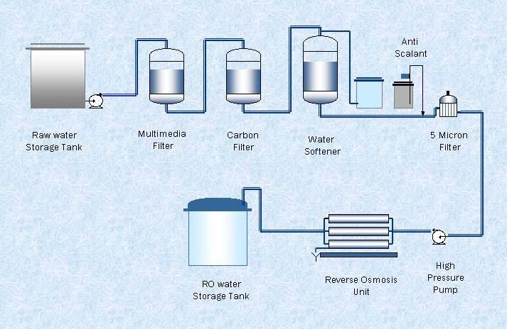

Figure.1.1

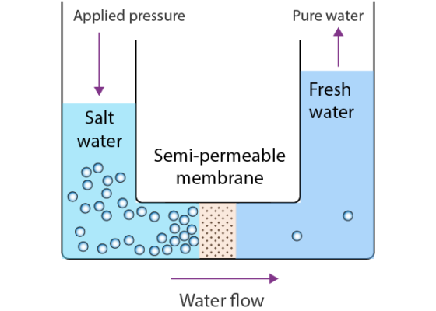

Figure.1.2

**COMPONENTS OF REVERSE OSMOSIS**

1. **COLD WATER LINE VALVES:** a valve that attaches to the supply pipe for cold water. The valve contains a tube that connects to the RO pre filter's intake side. The RO system's water supply comes from this.
2. **PRE-FILTER:** The Reverse Osmosis Pre Filter is initially filled with water from the cold water supply line. A Reverse Osmosis system may employ multiple pre-filters, the most popular of which are sediment and carbon filters. By eliminating sand, silt, mud, and other debris that could block the system, these pre-filters are utilized to PROTECT the RO membranes. Chlorine can harm RO membranes, thus it can be eliminated using carbon filters.
3. **REVERSE OSMOSIS MEMBERANE**: The system's beating heart is the reverse osmosis membrane. A wide range of pollutants, including those with an aesthetic or health impact, can be eliminated by the semipermeable RO membrane. The water enters a pressurized storage tank where treated water is kept after passing through the membrane.
4. **POST-FILTER:** The treated water travels through a final "post filter" after leaving the RO storage tank but before reaching the RO faucet. Typically, a carbon filter serves as the post filter. A post-filtration "polishing" filter eliminates any lingering flavors or aromas from the product water.
5. **Automatic Shut off Value (SOV):** The RO system features an automated shutoff valve that helps with water conservation. The automatic shut off valve closes when the storage tank is full to prevent any additional water from penetrating the membrane and to cease flow to the drain. The shutoff valve opens to allow the drinking water to pass through the membrane while the polluted wastewater is sent down the drain as soon as water is pulled from the RO faucet and the pressure in the tank reduces as a result.
6. **Check Value:** The output end of the RO membrane housing has a check valve. The check valve stops treated water from the RO storage tank from flowing backward. The RO membrane might be ruptured by a backflow.
7. **FLOW RESTRICTOR:** A flow restrictor controls how much water enters the RO membrane. The goal of flow controls, which come in a wide variety of designs, is to maintain the flow rate necessary to get drinking water of the greatest possible quality (based on the gallon capacity of the membrane). Additionally, the flow restrictor aids in maintaining pressure on the membrane's input side. Very little drinking water would be created if the flow control wasn't present since all incoming water would simply follow the line of least resistance and go down the drain. The RO drain line tubing is where the flow control is most frequently seen.
8. **STORAGE TANK:** The typical RO storage tank has a capacity of 2 to 4 gallons. When the tank is filled, a bladder inside maintains the water pressurized. Reverse osmosis tanks for under-counter use typically measure 12 inches in diameter and 15 inches tall.
9. **FAUCET:** The faucet that is included with the RO unit is mounted at the kitchen sink. Air gap faucets are required by plumbing codes in some places; however non-air gap types are more prevalent. There are also designer faucets available to match the design of your kitchen.
10. **DRAIN LINE:** This tube connects the drain to the outlet end of the housing for the reverse osmosis membrane. The wastewater with impurities and pollutants that the reverse osmosis membrane has removed is disposed of via the drain line tubing.

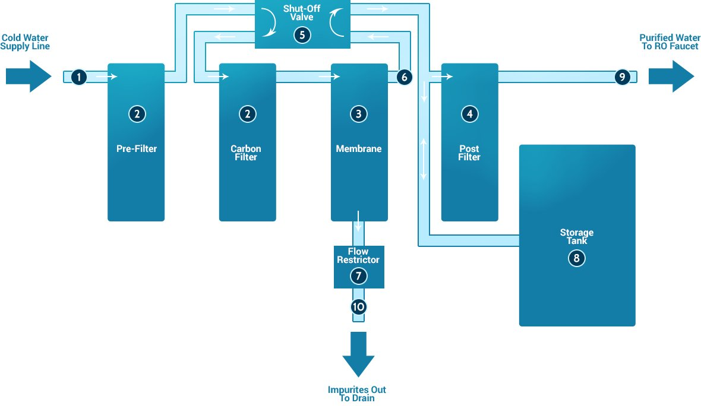

Figure.1.3

**ULTRA FILTRATION (UV)** One membrane filtering method that acts as a barrier to keep dangerous bacteria, viruses, and other pollutants out of pure water is ultrafiltration. A.02 micron membrane is forced through by an ultrafiltration machine for water. Particles in suspension that are too big to pass through the membrane adhere to the surface of the outer membrane. Only clean water and minerals in solution are allowed to pass.

The feed water flows either within the membrane material's hollow fibers’ shells or through the fibers’ lumens in ultrafiltration. Water and solutes with low molecular weight flow through the barrier, whereas suspended solids and solutes with a large molecular weight are trapped. Except for the size of the molecules it retains, ultrafiltration is not fundamentally different from reverse osmosis, microfiltration, or Nano filtration. UF is perfect for removing colloids, proteins, bacteria, pyrogens, proteins, and macromolecules larger than the membrane pore size from water when strategically combined with other purification technologies in a complete water system.



Figures.1.4

**Ultra Violet disinfection (UV)** is the UV Disinfection System is a very powerful tool for eradicating microbiological contaminants from water. However, for UV-C radiation to successfully disinfect the water, bacteria must be exposed to it in the right quantity. UV disinfection systems have a wide range of uses, including the treatment of industrial wastes as well as the purifying of drinking water for individual households and whole townships. For industrial applications, UV water treatment is acknowledged as a safer and more economical method of water disinfection**.**

Any application where microbial-free, safe, and pure water is required and there is a risk of the water becoming contaminated before it reaches the final point of use can benefit from UV sanitization.

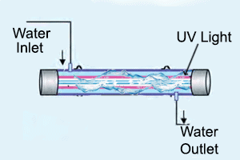

Figure.1.5

**REVERSE OSMOSIS VS ULTRA FILTRATION**

A hollow fiber membrane, which is used in many ultrafiltration systems, filters water from the inside out. Particles can attach to a lot of surface area because to this. Some membranes filter from the outside in, such as the spiral wrapped RO membrane. A TFC reverse osmosis membrane cannot handle any chlorine, but the hollow fiber membrane is very resistant to oxidants and chlorine.

Because the RO membrane has the lowest particle size, a reverse osmosis system offers the most thorough filtration, although this degree of filtration is not always required or preferred. Beneficial minerals that a RO system eliminates are kept by a UF system. This implies that dissolved salts, fluoride, or TDS cannot be removed by an ultrafiltration system. While a reverse osmosis system requires a booster pump to improve water flow, an ultrafiltration system may function with low water pressure as well.

**TRENDS OF WATER PURIFIER NOW A DAYS :**

1. **Slimmer Product Profile**

People are being forced to live in fewer places all throughout Asia as a result of rising housing costs and an increase in rural-urban migration. Customers are seeking for solutions that will not only save space but also aid in clearing clutter because there is less counter and storage space for appliances. The industry for water purifiers is responding to this trend by creating smaller, more streamlined solutions. The MyHANDSPAN product line, for instance, was created by Coway and has purifiers that are no larger than the width of your hand. It makes sense that Bosch Thermo technology created the Bosch AQ series household water purifiers, which are made to fit under the counter and out of sight because more counter space can even be thought of as a luxury.

In the meanwhile, product managers must continue to compete for more room in consumers' kitchens by inventing smaller and slimmer water purifiers because it is doubtful that residences in Asia will become bigger any time soon.

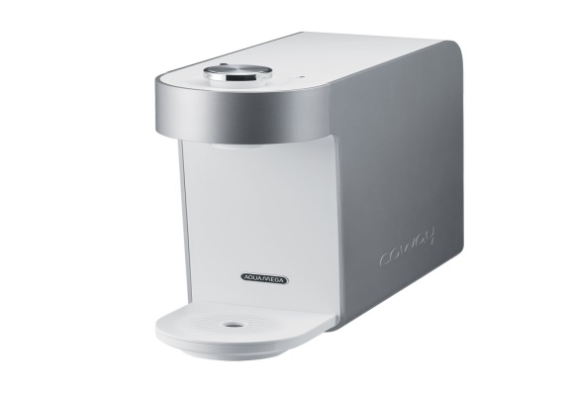

1. **Re-Mineralization For Taste And Health:**

Water purifiers are vying for market share now that alkaline and pH-balanced water is a growing trend in the bottled water sector. Their cause is strengthened by the rising demand for wellness-related products and services, as firms from the Consumer Packaged Goods (CPG) sector are attempting to capitalize on the $30 billion that Americans spend on "complementary health methods." One business, Mitte®, offers a smart home water solution that improves water through re-mineralization in addition to filtration. Its distinguishing feature? The water in Mitte is not only clean, but also beneficial.

1. **Growing Need For Disinfection:**

Around the world, 2.1 billion people lack access to clean water, with 289 million of them living in Asia and the Pacific. The risk of coming into contact with E. coli bacteria as opposed to other waterborne viruses is exceptionally high in Asia due to the widespread pollution of water sources with industrial and urban waste. Water disinfection must thus be a primary priority for water purification companies. As a result, we are witnessing purifier ratings that differ from NSF class A/B and shift to updated ratings like 3-log E. coli. In comparison to greater degrees of disinfection, this offers adequate ongoing protection for drinking water systems, but it can be done more cheaply and with a smaller footprint.

**LATEST TECHNOLOGIES OF WATER PURIFIER**

1. **Nanotechnology:**

Numerous methods and procedures for applying materials at the atomic or molecular level are used in nanotechnology. When compared to traditional water filtration techniques, nanotech-based water purification procedures are thought to be modular, extremely effective, and affordable.

Nanoparticles made of silver, copper, and zero-valent iron (ZVI), as well as nanostructured photo catalysts, nano-membranes, and nano adsorbents, are among the principal uses of nanotechnology in water treatment processes.

The increased surface-to-volume ratio of nanoparticles facilitates the separation of pollutants at extremely low concentrations while improving the adsorption of chemical and biological particles. Nano adsorbents have certain physical and chemical characteristics that are ideal for removing metallic contaminants from water.

Carbon nanotubes (CNTs) are considered to be one of the prominent nanomaterials used in water purification. CNT-based filtration systems can remove organic, inorganic and biological compounds from water.

Global companies such as Alfa Laval, Applied Membranes, DowDuPont, GEA Group, Inopor, and Koch Membrane Systems are involved in the development of membranes that are made of nanomaterials to eliminate pollutants during the treatment.

## Acoustic nanotube technology:

## Scientists at NASA's Johnson Space Center created the acoustic nanotube technology. To force water through tiny carbon nanotubes, it uses acoustics rather than pressure.

## The system relies on a carbon nanotube-integrated molecular screen that is driven by acoustics to permit water molecules through while inhibiting bigger molecules and impurities. It uses less energy than conventional filtration methods and forces water away from impurities rather than eliminating them. Additionally, the technique does away with the requirement to flush the filter system.

## Municipal water plants, healthcare facilities, labs, distilleries, desalination plants, industrial facilities, wastewater treatment plants, and consumer markets are the main markets for acoustic nanotube technology. With the integration of several filters, the invention may be scaled to meet the filtration requirements of customers.

## The companies may licence NASA's patented acoustic nanotube technology to develop it into a line of commercial water filtration products.

## Photo catalytic water purification technology:

## Due to its effectiveness in purifying tainted water, photo catalysis has been increasingly popular in recent years. Using photo catalyst and ultraviolet (UV) radiation, the method purges hazardous materials from water.

## Aquaporin Inside™ technology:

## The bio-mimetic water treatment membrane design is the foundation of the Aquaporin InsideTM technology from the Danish cleantech business Aquaporin. Rapid and extremely selective water transport across the cell membrane is made possible by aquaporins. They enable the cell to regulate its internal osmotic pressure and volume in accordance with the variations in hydrostatic and osmotic pressure.

## 

## *The unique architecture of aquaporins enables rapid, highly selective water transfer across the cell membrane. Credit: Art of Science / Shutterstock.*

## Automatic Variable Filtration (AVF) technology:

## In a straightforward procedure, Automated Variable Filtration (AVF) technology uses downward flow of filter media to clean upward flow of influent. It does away with the requirement for any extra procedures or freshwater for cleaning filter material.

## CONCLUSION:

## Our filtering techniques worked well throughout this experiment even though they were only used on a modest basis. The pH, hardness, chlorine, and alkalinity levels of the water at Garland High School may all be improved if this technique was made more widespread. Because of the improved water quality, it is safer to consume.

## The most efficient way was the use of activated charcoal, which may also be used to purge water and the environment of airborne pollutants and gases. The activated charcoal was beneficial for the ecosystem as a whole in addition to helping to filter the water. Carbon is the most eco-friendly alternative for water filtration because it is a natural resource and is reasonably priced.

## Additionally, the carbon emissions produced when activating it to the point at which it can filter water can be reduced by activating the material with boiling water.

## By finishing this study, we gained a better understanding of alternative water filtering techniques, their usefulness, and their advantages. By using these secure, affordable, and efficient water filtering methods, health risks associated with low quality water may be avoided.

**REFERENCE :**

* <https://en.wikipedia.org/wiki/Water_purification>
* <https://en.wikipedia.org/wiki/Reverse_osmosis>
* <https://www.appropedia.org/UV_disinfection>
* <https://www.cdc.gov/niosh/topics/nanotech/default.html#:~:text=Nanotechnology%20is%20the%20manipulation%20of,%2C%20energy%2C%20materials%20and%20manufacturing>.
* <https://www.nasa.gov/centers/johnson/techtransfer/technology/MSC-24180-1_Water-Filtering-Device.html>